Report

Assignment 1

*2DV608*

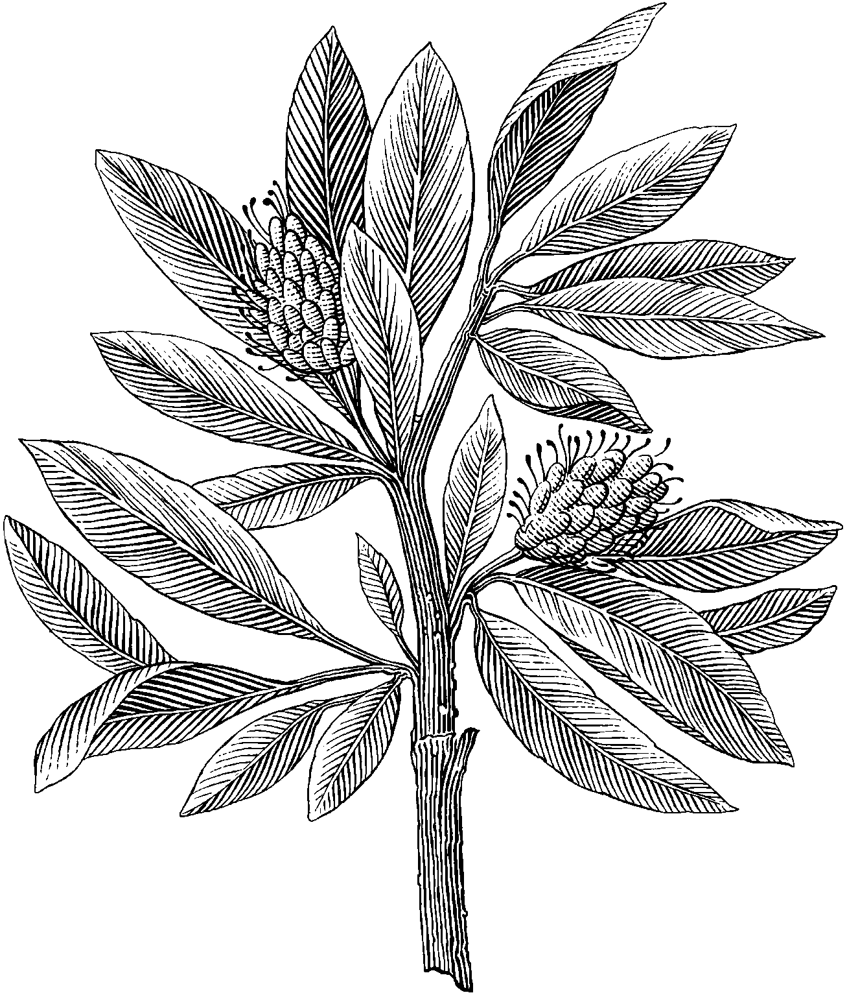

*Author:* Xingrong Zong

*Semester:* Spring 2021

*Email:* xz222bb@student.lnu.se

Table of Contents

1. Introduction 1-2

1.1 Purpose of the requirements document 1-2

1.2 Scope of the product 1-2

1.3 Definitions, acronyms, and abbreviations 1-2

1.4 References 1-2

1.5 Overview of the remainder of the document 1-2

2. General description 2-3

2.1 Product perspective 2-3

2.2 Product functions 2-3

2.3 User characteristics 2-3

2.3.1 Discussion 2-3

2.4 General constraints 2-3

2.4.1 Discussion 2-3

2.5 Assumptions and dependencies 2-3

3. Specific functional, non-functional, and interface requirements 3-4

3.1 Discussion 3-4

4. Appendices 4-5

4.1 Discussion 4-5

5. Index 5-6

5.1 Discussion 5-6

# Introduction

## Purpose of the requirements document

## Scope of the product

## Definitions, acronyms, and abbreviations

## References

## Overview of the remainder of the document

# General description



## Product perspective

## Product functions

## User characteristics

### Discussion

## General constraints

### Discussion

## Assumptions and dependencies

# Specific functional, non-functional, and interface requirements

Eg: external interfaces, functionality, performance requirements, logical database requirements, design constraints, system attributes, and quality characteristics



## Discussion

# Appendices



## Discussion

# Index



## Discussion